**LAB 3**

1.Create a keyspace by name Employee

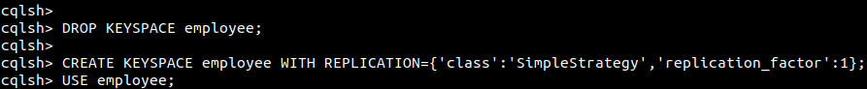

2. Create a column family by name Employee-Info with attributes Emp_Id Primary Key, Emp_Name, Designation, Date_of_Joining, Salary,Dept_Name.  
3. Insert the values into the table in batch.

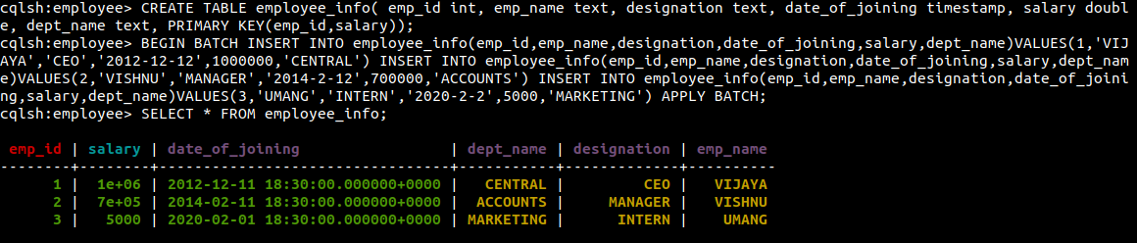

1. Update Employee name and Department of Emp-Id 3

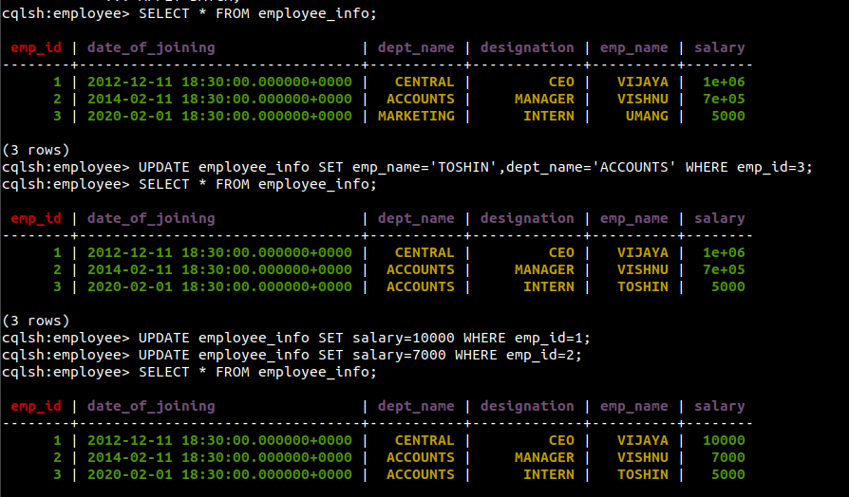  
  
5. Sort the details of Employee records based on salary  
  
6. Alter the schema of the table Employee_Infoto add a column Projects which stores a set of Projects done by the corresponding Employee.

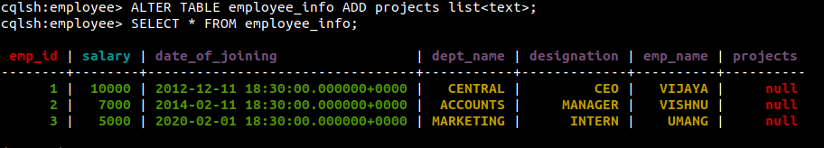

7. Update the altered table to add project names.  
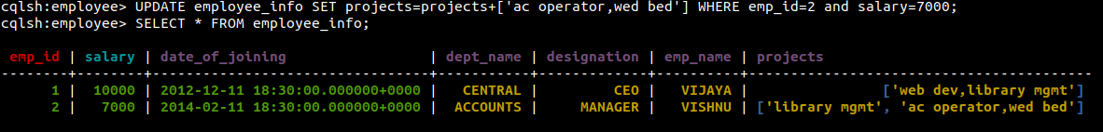  
8.Create a TTL of 15 seconds to display the values of Employees.